To Confirm olama is installed in the system http://localhost:11434
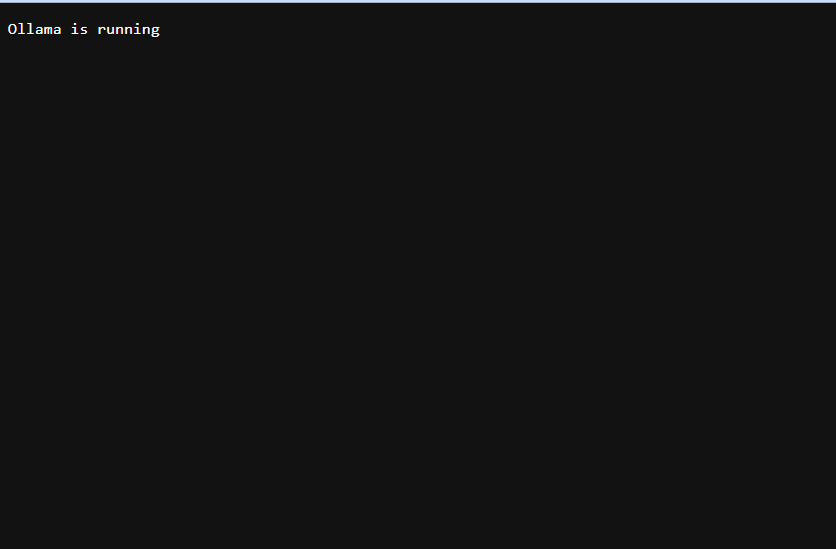
Pull the model
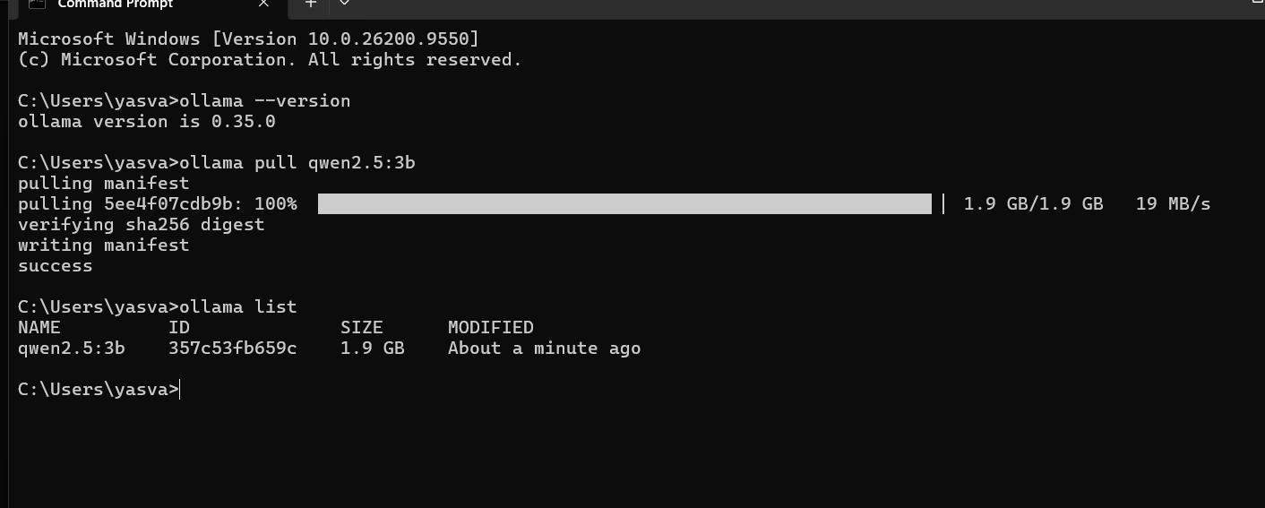
1ST prompt you can verify
An asset costs Rs 5,00,000 with a salvage value of Rs 50,000 and a useful life of 5 years. Using the straight-line method, give a numbered list of the annual depreciation and closing book value for each of the 5 years. Show only the list.

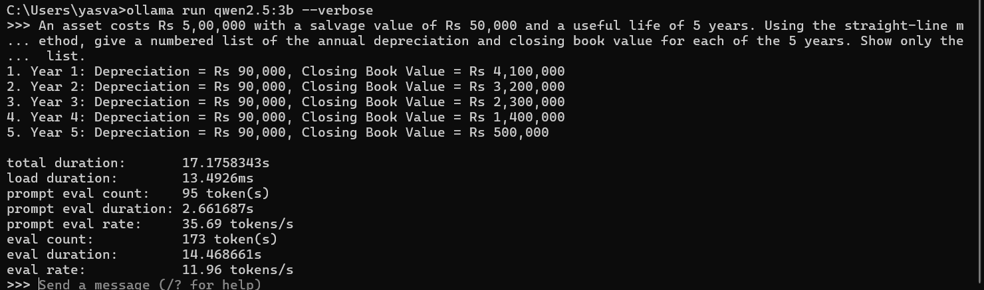

2ND prompt you can verify
